Acceptance tests   
“Acme Rookies v1.0”

|  |  |
| --- | --- |
| Development team | |
| **Identifier** | *G92* |
| **Members** | *Batista Núñez, Francisco.*  *de la Flor Bonilla, Álvaro.*  *Fernández Benjumea, Carmen.*  *Ferrete Molle, José Antonio.*  *Salvat Pérez, Antonio Manuel.*  *Sanchez Hipona, Antonio.* |
| **Testing team** | |
| **Identifier** |  |
| **Members** |  |
| **Indexing data** | |
| **Test designers** | *Salvat Pérez, Antonio Manuel.*  *If you need to contact me:*  *antoniosalvatperez@gmail.com*  *+34 673 53 28 89* |
| **Testers** |  |
| **Notes** | *Use cases of R23.2* |

**Table of contents**

Use case 23.2.1: Logged , send a message 3

Use case 23.1.2: Logged, delete the message 10

# Use case 23.2.1: Logged , send a message

Description

An user logged must be able to manage his message, which includes creating,listing, and deleting them.

Access

First, the user must log in the login page. User: admin, Password: admin

The steps to follow are explained down.

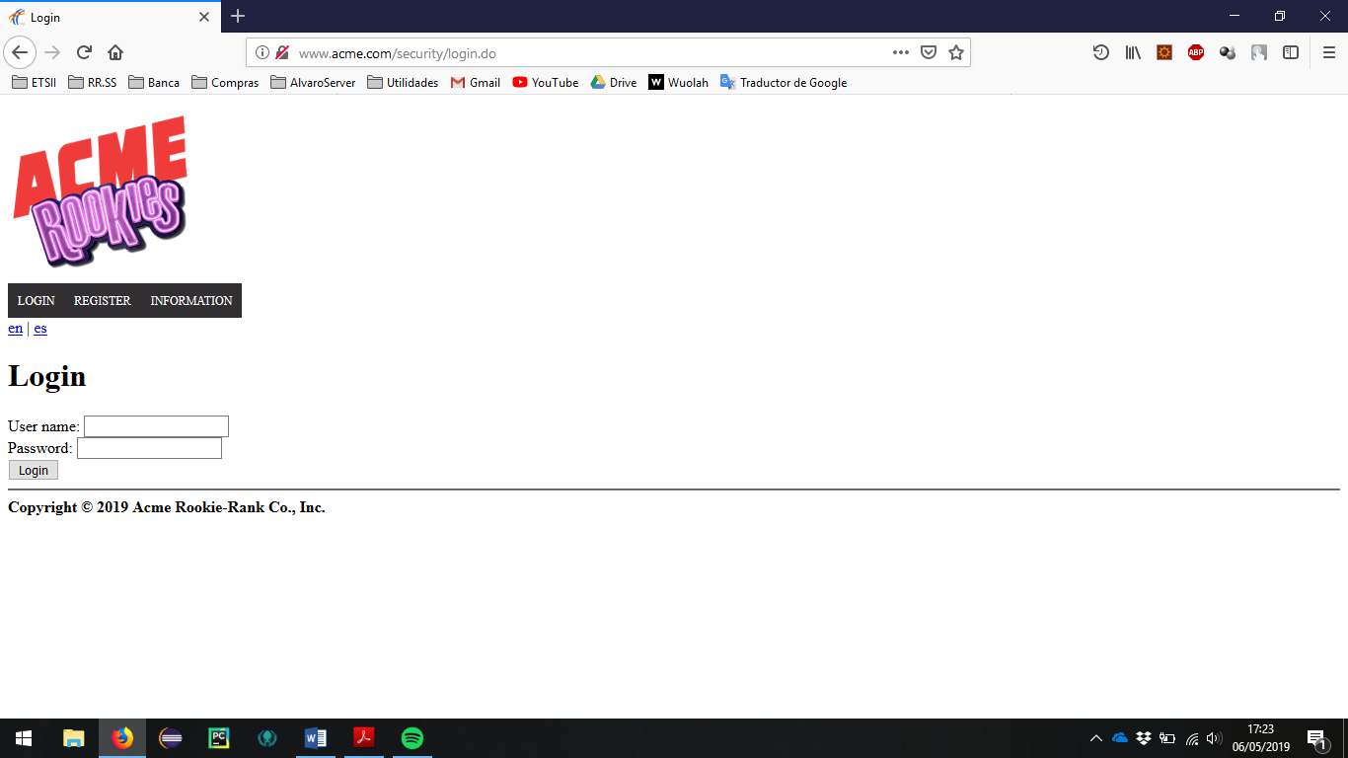

Go to the section of user profile.

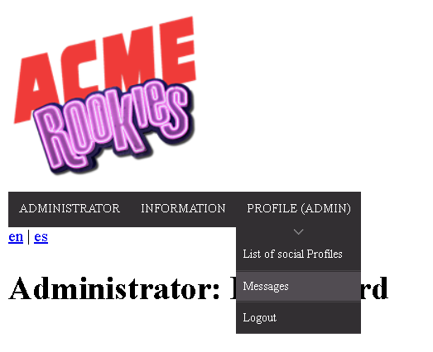

> Header Menu > Display the "PROFILE" options > Messages

The list of sended messages and received messages should appear. The lists are empty because there aren´t messages in the populate.

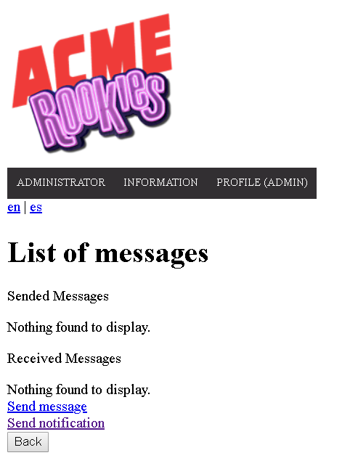

The user must click on the button “Send message” to redirect to the view of sending a message. In this view we find four fields, one for the subject of the message, one for the body, one for the tag and one for choosing the recipient.

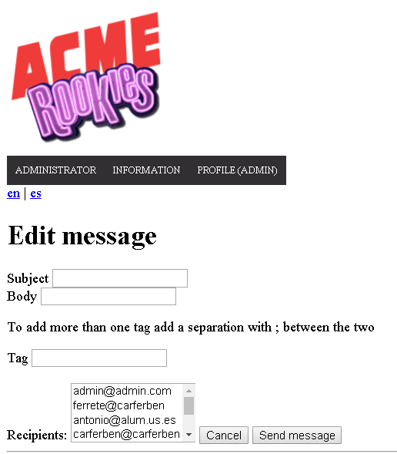

Tests

|  |  |
| --- | --- |
| Test 1 | |
| **Description** | Click on the button to create a new message and fill it with invalid data. |
| **Expected** | A form with four fields must appear, being 3 completeness mandatory.  After sending the form with erroneous fields, the error messages should appear right next to the field that they have completed in the wrong way and the message should not be saved under any circumstances if an error is still present. |
| **Outcome** |  |
| **Notes** |  |

|  |  |
| --- | --- |
| Test 2 | |
| **Description** | Re-complete the previous form but with valid data. |
| **Expected** | If all the fields have been completed correctly the system will send the message and redirect to the list view of the messages.  Make sure that all the fields are correct. |
| **Outcome** |  |
| **Notes** |  |

|  |  |
| --- | --- |
| Test 3 | |
| **Description** | Correct listing. |
| **Expected** | Check that the list of message is correct and make sure that the new message created now appears |
| **Outcome** |  |
| **Notes** |  |

|  |  |
| --- | --- |
| Test 4 | |
| **Description** | Add a new message to the list. |
| **Expected** | When adding a new message with a tag with order previous to the previous message, we see that the list is reordered according to the tag |
| **Outcome** |  |
| **Notes** |  |

|  |  |
| --- | --- |
| Test 5 | |
| **Description** | Show message |
| **Expected** | Click the subject to redirect at the show of a message.Check that the data of the message is correct |
| **Outcome** |  |
| **Notes** |  |

|  |  |
| --- | --- |
| Test 6 | |
| **Description** | Try to do GET hacking to the system (I). |
| **Expected** | Copy the edit URLs, and try to enter to the show of a meesage. Try it without login and with an actor who is neither the one who sends it nor the one who receives it. In this case the recipient is the actor with credentials -> user:provider password:provider, for this actor the test not make sense.    Depending on the populate the id of the message may vary so to make sure you have that id you would have to enter the show of that message before and see its url  You can use, as an example:  /message/show.do?messageId=32770  Being 32770 the ID of the entity to edit.  The system must redirect to the start tab or to the log in view in the case of a not login |
| **Outcome** |  |
| **Notes** |  |

# Use case 23.1.2: Logged, delete the message

Description

If a message is deleted and it doesn’t have tag “DELETED” then it gets tag “DELETED”, but it’s not actually deleted from the system; if a message with tag “DELETED” is deleted, then it’s actually removed from the system

Access

First, the user must log in the login page. User: admin, Password: admin

Then follow the steps described above to get to the list of message.

Tests

|  |  |
| --- | --- |
| Test 1 | |
| **Description** | Delete a message |
| **Expected** | In the message list click on the subject of message, the selected message should set her tag to “DELETED” in case yours is distant.      Click on delete button    The tag have been change to “DELETED” |
| **Outcome** |  |
| **Notes** |  |

|  |  |
| --- | --- |
| Test 2 | |
| **Description** | The same test but with the tag deleted |
| **Expected** | In this case the message should be delete of her list but not of the system because the recipient haven't deleted it.        The recipient(actor user:provider password:provider) have the message with the sended tag. |
| **Outcome** |  |
| **Notes** |  |

|  |  |
| --- | --- |
| Test 3 | |
| **Description** | Repeat the test 1 and 2 with the provider |
| **Expected** | Here we are going to check that in the case that one actor remove a message and no one apart from he have the message, the message will be remove from the system.    The message have been remove. |
| **Outcome** |  |
| **Notes** |  |

|  |  |
| --- | --- |
| Test 4 | |
| **Description** | Delete a message hacking |
| **Expected** | We are going to check than an actor that not contains the message or arent logged can´t remove the message  Try this:  message/delete.do?id=65538  with an actor that won´t be the actor(admin/admin) or the actor(provider/provider).  The system should redirect to the start tab |
| **Outcome** |  |
| **Notes** |  |